Prompt：Please strictly adhere to the Standard Operating Procedure (SOP) for this task. The object to be handled is a blue, hollow plastic box. The Pick Station is designated as Pick Station 5, and the Place Station is designated as Place Station 2.

JCIIOT 2026 Standard Operating Procedure (SOP)
Material Handling Task Execution Manual for Electronics Factory Operations
Task Name: Material Handling Task
Task ID: SOP-ELC-001-2026-GEN
Version: 2.0
Effective Date: April 23, 2026
Application: Material handling operations in electronics manufacturing facilities
Document Type: Standard Execution Document

1. Purpose
This SOP provides standardized guidance for operators or automated handling systems performing material transfer tasks within an electronics factory. Its purpose is to ensure that materials are moved from the designated pickup location to the designated placement location in a safe, controlled, and repeatable manner.
This procedure is intended to support:
- Safe task execution
- Accurate material identification and handling
- Stable transport performance
- Reliable placement at the destination
- Clear traceability of task status and exceptions
This document may be used for routine operations, operator guidance, training, project delivery documentation, or on-site execution support.

2. Task Overview
In this task, the operator or automated system is required to collect a target item from a defined pickup point and deliver it to a designated placement point. Throughout execution, the system must remain responsive to environmental changes, route conditions, and material stability in order to prevent mispicks, drops, collisions, or incorrect placement.
2.1 Task Objective
Transfer the target material from Pick Station to Place Station in accordance with operational safety and quality requirements.
2.2 Core Execution Requirements
- Identify the correct target material
- Reach the pickup point safely
- Perform a reliable pick action
- Transport the material in a stable manner
- Place the material accurately at the destination
- Complete task recording and end-of-task handling

3. Pre-Operation Preparation
3.1 Task Information Verification
Before starting the task, confirm the following:
- The task has been correctly issued
- The pickup location is defined as Pick Station
- The destination is defined as Place Station
- The target material type has been specified
- The required handling quantity is clear
3.2 Target Material Confirmation
Before execution, verify the target item based on the task instruction. The following aspects should be checked:
- Visual appearance of the material
- Color, shape, label, or identifying features
- Current placement position
- Accessibility of the gripping area
3.3 Equipment Readiness Check
Before starting the task, ensure that the following functions are available and operating normally:
- Navigation system
- Gripper or end-effector
- Vision or identification system
- Safety protection functions
- Overall machine operating condition
3.4 Work Area Condition Check
Confirm that the work environment supports safe task execution:
- Pathways are clear
- The pickup area is not obstructed
- The placement area is available
- No obvious safety hazards are present nearby
- Lighting and visibility are sufficient

4. Standard Operating Procedure
Step 1: Move to the Pick Station
Operating Instructions
- Start the task execution sequence.
- Navigate to the designated pickup point: Pick Station.
- Stop in the correct operating position upon arrival.
- Check whether the surrounding area is suitable for material pickup.
Inspection Points
- The pickup location is correct
- The operating area is clean and accessible
- The target material can be clearly identified
- No obstacle or interference risk is present

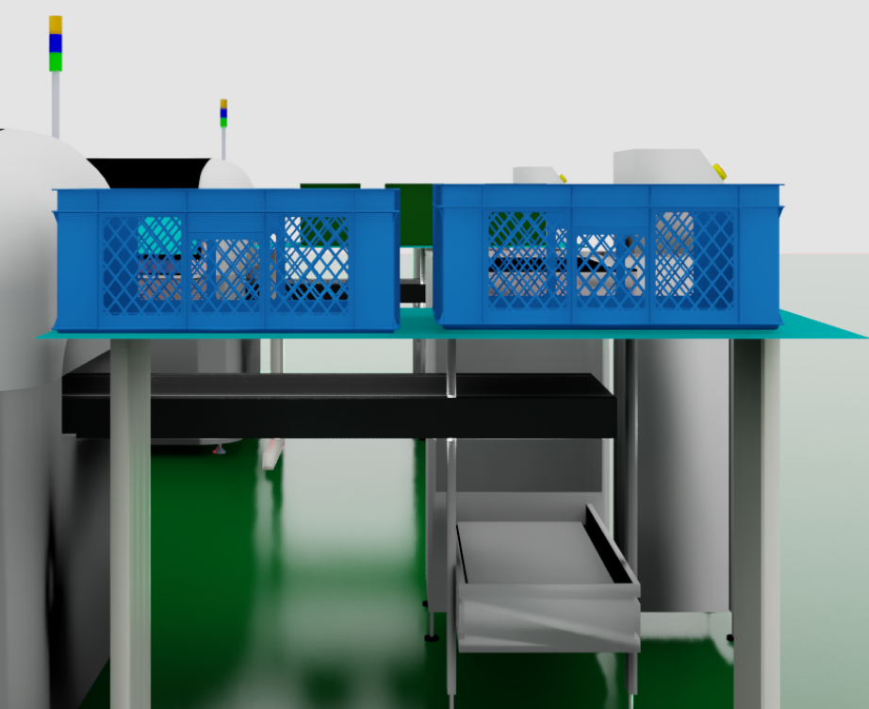
Step 2: Identify and Pick the Target Material
Operating Instructions
- Activate the identification or vision function at Pick Station.
- Locate the target material precisely.
- Evaluate the material pose, boundaries, and pick feasibility.
- Plan a safe picking path that avoids surrounding items or equipment.
- Execute the pick action smoothly and accurately.
- After gripping, verify that the material is securely held.
Inspection Points
- The correct item has been selected
- The gripping point is appropriate
- No collision occurred during approach or pickup
- The item is not at risk of slipping
- The held position is stable after pickup
Execution Requirements
- Movements must be controlled and smooth
- Rough handling is not permitted
- Incorrect material pickup must be avoided
- The gripper path must not cause unnecessary interference

Step 3: Navigate to the Place Station
Operating Instructions
- After a successful pick, generate a route from Pick Station to Place Station.
- Select a route that is both safe and operationally efficient.
- Monitor the environment continuously during transport.
- If an obstacle is detected, slow down, stop, or replan the route as necessary.
- Keep the material stable throughout the entire transport phase.
Inspection Points
- The transport route is valid and safe
- Temporary obstacles are properly handled
- The material remains stable during movement
- Collision risk with nearby objects is controlled
- The system remains in a safe operating state
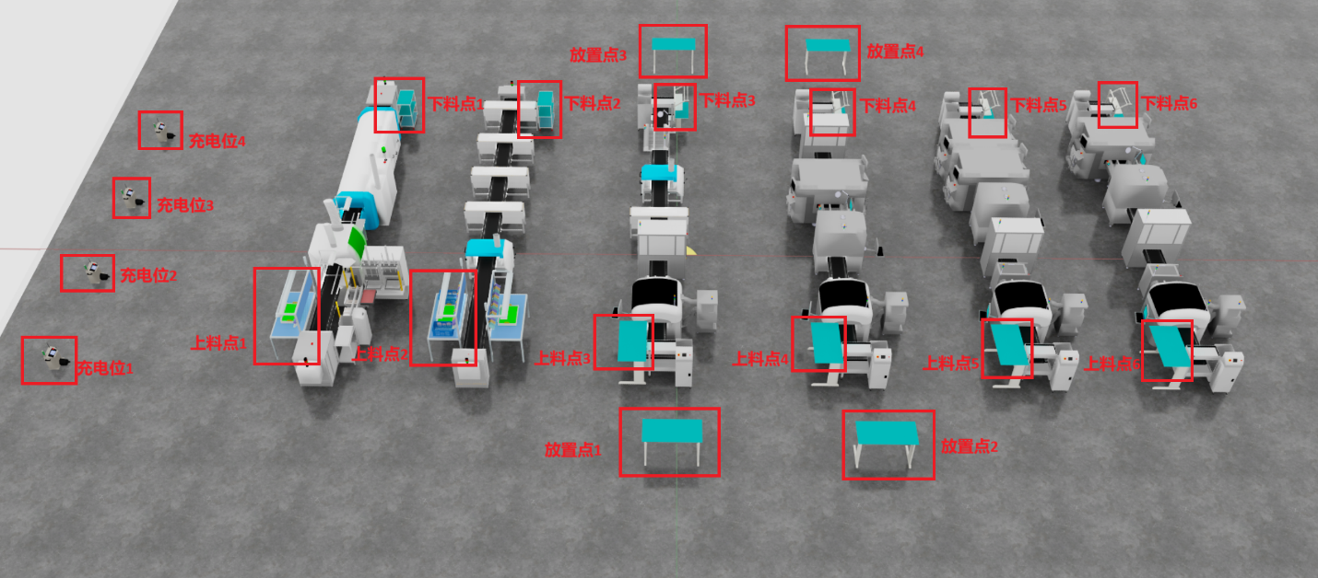
Step 4: Place the Material at the Place Station
Operating Instructions
- Upon arrival at Place Station, inspect the drop-off area first.
- Confirm that the target placement area is free of interference or occupancy.
- Move the material above the designated placement position.
- Lower the material gradually and complete the placement action.
- Release the gripper gently to ensure stable placement.
- Verify the final status of the material after release.
Inspection Points
- The placement area is available and suitable
- The material is positioned within the designated zone
- No tipping, offset, or overhang is present
- The item remains stable after release
- The placement does not interfere with subsequent operations
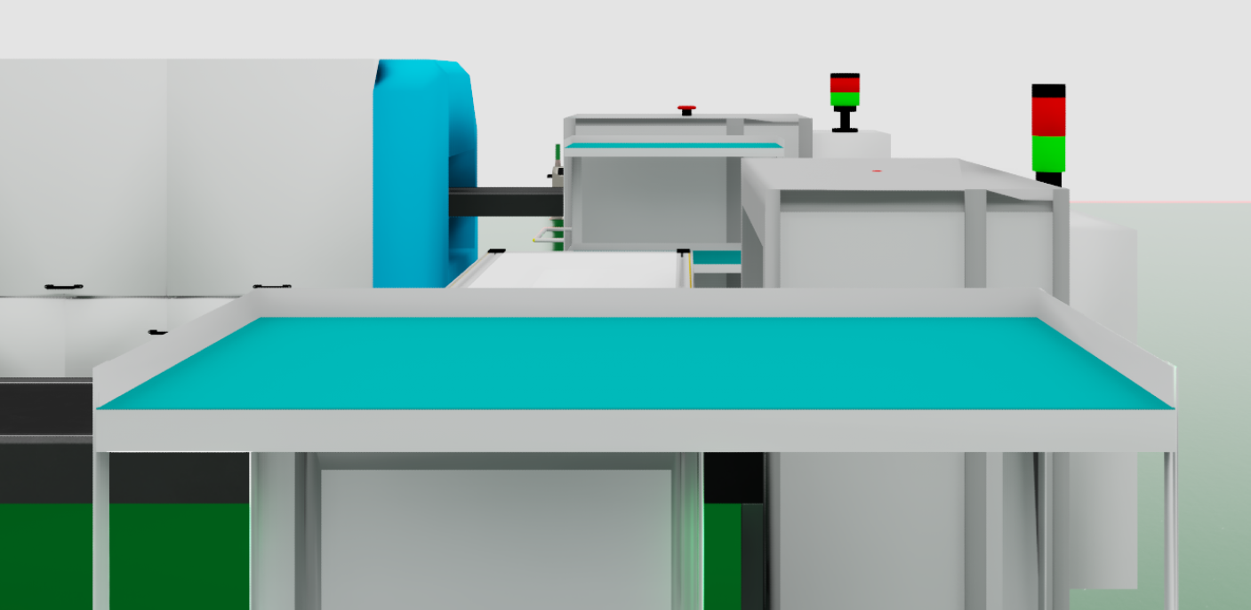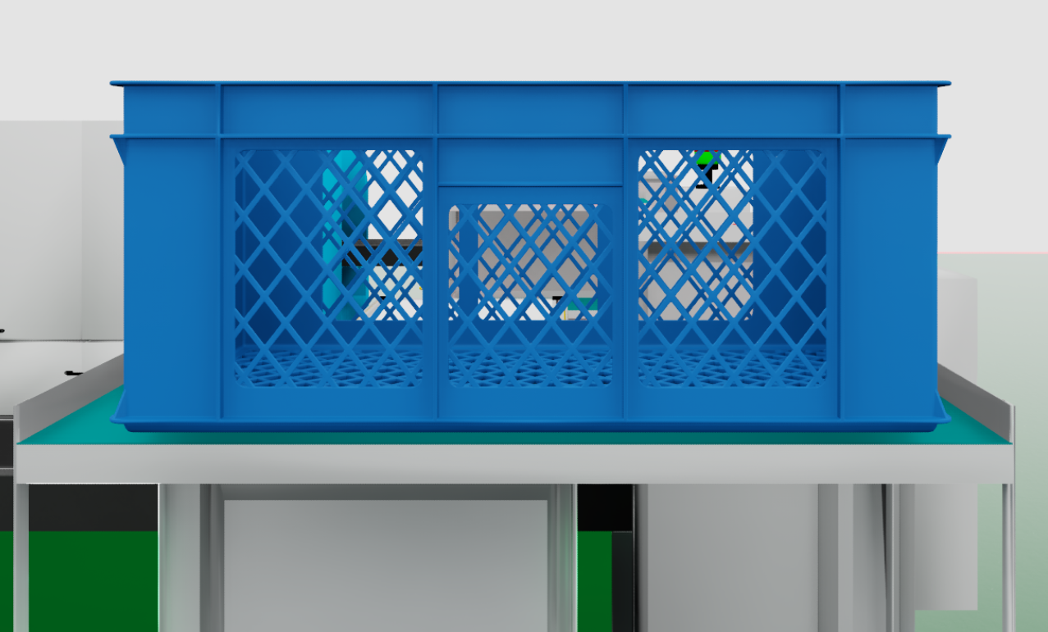
Step 5: Repeat the Task if Multiple Items Are Required
Operating Instructions
- If more than one item must be transferred, return to the pickup process for the next item.
- Each cycle must include identification, pickup, transport, and placement verification.
- Every handled item must independently meet the required safety and quality criteria.
Notes
- Verification steps must not be skipped
- Repetitive operation does not eliminate the need for safety checks
- Each completed transfer should be treated as an individual confirmed action

Step 6: Complete the Task and Close Out
Operating Instructions
- Confirm that all required materials have been transferred.
- Verify that the completed quantity matches the task instruction.
- Return to the designated standby area or prepare for the next task.
- Record the task result and key execution information.
- If any exception occurred, document it accordingly.
Inspection Points
- All required items have been transferred
- No missing, extra, or misplaced material remains
- The system has returned to standby or ready status
- Task records are complete

5. Exception Handling
5.1 Collision Event
If a collision occurs during movement or manipulation, the following actions shall be taken:
- Stop all motion immediately
- Inspect the material, equipment, and surrounding area
- Assess whether safe recovery is possible
- Attempt to generate a new safe route if appropriate
- Report the exception if the issue cannot be resolved directly
5.2 Material Drop
If the material is dropped during handling:
- Stop the operation immediately
- Assess the condition of the material and nearby environment
- Reattempt pickup only if it is safe to do so
- Report the issue if safe recovery is not possible
5.3 Route Blockage
If the path becomes blocked:
- Slow down or stop at a safe distance
- Reassess the local environment
- Generate an alternate route if available
- Pause the task and report the issue if no safe route exists
5.4 SOP Mismatch with Site Conditions
If the actual site condition differs from the procedure description:
- Stop the operation immediately
- Notify the responsible supervisor or coordinator
- Describe the discrepancy clearly
- Wait for further instruction
- Do not modify the process without approval

6. Safety Requirements
6.1 General Safety Principles
- Safety takes priority over speed
- No task may continue under uncontrolled abnormal conditions
- Continuous awareness of environmental change is required
- Risks to personnel, equipment, and materials must be avoided at all times
6.2 Material Handling Safety
- Materials must not be dropped
- Materials must not collide with surrounding objects
- Excessive shaking or unstable transport is not allowed
- Transport must not continue if gripping stability is uncertain
6.3 Placement Safety
- The destination area must be verified before placement
- Placement actions must be slow and controlled
- Final stability must be confirmed after release
- The material must remain within the designated placement boundary

7. Quality Requirements
To meet task quality standards, the following conditions shall be satisfied:
- Correct target item identification
- Successful and controlled pickup
- No collision or drop during transport
- Accurate placement at the destination
- Stable final material condition
- Complete and traceable task records

8. Records and Documentation
8.1 Required Records
At minimum, the following records shall be retained after task completion:
- Task execution record
- Completion status record
- Exception report, if applicable
- Image-based supporting records, if applicable

